3GPP TSG-RAN WG4 Meeting #119 R4-2605758
Dalian, China, 18th – 22th May 2026

Source: Huawei, HiSilicon
Title: On 6GR Sensing feasibility study
Agenda Item: 8.10.3
Document for: Approval

Introduction
In RAN4#118bis, the agreement [1] on the feasibility study for 6G sensing is excerpted as below.
- Agreement
  - Agreement for the feasibility study for 6G sensing:
    - UAV (passive object), TRP monostatic
      - FFS on Multiple TRP monostatic.
    - Vehicle (passive object), TRP-UE bistatic
    - [TBD] (passive object), UE-TRP bistatic
    - UAV (passive object), TRP-TRP bistatic
    - In addition to above cases, other sensing modes/scenarios as agreed by RANP and RAN1 could be also studied.
- Agreement
  - Agreement for the prioritized bands to be investigated for 6G sensing
    - FR1 TDD bands +FR2-1 TDD bands;
    - Encourage inputs from the operators for the bands;
- Agreement
  - RAN4 to use the same 6GR BS and UE assumptions for 6G sensing study as starting point;
- Agreement
  - For the feasibility study of mono-static (TRP, UE), propose to consider the following factors:
    - Whether to consider the Tx/Rx separate panels for TRP;
    - Whether to consider the Tx/Rx separate antennas for UE;
    - FFS on the switching time for Tx/Rx switching;
    - FFS on Self interference
    - Quality of received reflected signal
    - Receiver linearity and blocking etc
    - Others are not precluded.
  - The operation mode/sensing waveform depends on the design from other WGs.
- Agreement
  - For the feasibility study of TRP-UE and/or UE-TRP bi-static, propose to consider the following factors:
    - FFS for Sensing node’s receiver dynamic range
    - Quality of received reflected signal
    - Synchronization between TRP and UE
  - Others are not precluded.
This contribution provides our further considerations on feasibility study for 6G sensing.

Discussion
In last RAN4#118bis meeting, it was agreed that the sensing scenario is identified by the combination of sensing target and sensing mode. We propose to prioritize the study of aNB mono-static based UAV sensing and aNB-UE/UE-aNB bi-static based vehicle sensing from RAN4 perspective, which is detailed in [2].

aNB mono-static sensing
For the UAV sensing scenario, Rel-20 5GA carried out substantial evaluations of aNB mono-static sensing and completed the study from RAN1 perspective. To guarantee the continuous coverage of UAV sensing, aNB needs to transmit pulse and continuous wave signals at different time to sense the short-ranged and long-ranged targets, respectively. Figure 1 shows the aNB mono-static based UAV sensing with mixed waveforms.
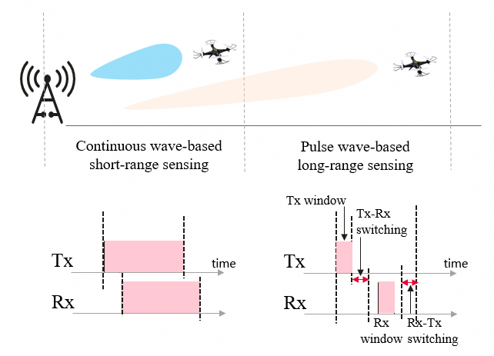
Figure 1: aNB mono-static based UAV sensing with mixed waveforms.
Observation 1: For aNB mono-static based UAV sensing scenario, aNB needs to transmit pulse and continuous wave-based signals to sense the short-ranged and long-ranged targets, respectively.
- Pulse wave-based long-range sensing
For pulse wave-based aNB mono-static sensing, the time within a single symbol is divided into four parts: Tx window, Tx-Rx switching time, Rx window, and Rx-Tx switching time. aNB transmits the pulse signals in the Tx window and receives the reflected/scattered signals in the Rx windows, which means the transceiver works in a TDM manner. The aNB cannot receive the reflected signals before the Rx window, so the minimum sensing range for pulse wave-based sensing is determined by the sum duration of Tx window and Tx-Rx switching time.
In 5G NR, the Tx-Rx switching time for TDD is defined as 13$μs$ for FR1 and the corresponding minimum sensing range exceeds 1.95 km irrespective of the Tx window time. The CP length for continuous wave-based sensing with SCS of 30KHz is 2.34$μs$, corresponding to maximum sensing range of 351m. Therefore, the low-altitude airspace could not be continuously covered within the existing Tx-Rx switching time in NR.
To enable continuous coverage of sensing, the sum period of Tx window and Tx-Rx switching time can be considered not to exceed the CP length of signals in continuous wave-based sensing, which is related with SCS and frequency bands. Irrespective of Tx window time, the Tx-Rx switching time could be considered below 2.34$μs$, when the SCS of signal is 30 KHz in continuous wave-based sensing, but the feasibility of such value should be further studied.
Observation 2: For pulse wave-based aNB mono-static sensing, aNB transmits and receives signals in a TDM manner, and the minimum sensing range is determined by the Tx-Rx switching time interval.
- Continuous wave-based short-range sensing
For continuous wave-based aNB mono-static sensing, e.g. CP-OFDM, aNB needs to concurrently transmit and receive signals in a full-duplex manner. In order not to block receiver and to facilitate valid sensing, aNB needs to ensure a larger Tx-Rx antenna panel isolation, which has an impact on the transmit power and dynamic receiving power range. It should be noted that different from Rel-19 SBFD, the aNB performing mono-static sensing transmits and receives signals at the same band, whose RF feasibility needs further studied.
Observation 3: For continuous wave-based aNB mono-static sensing, aNB transmits and receives concurrently in a full-duplex manner, and needs to lower the transmit power under the restriction of Tx-Rx antenna panel isolation.
Another issue specific to sensing is larger dynamic ranges of receiving signal power. For sensing, the received signal contains the scattered/reflected paths from targets with different distances, the dynamic ranges of the power of different paths become even larger when considering the leakage signal from Tx panel to Rx panels. Therefore, a larger signal received sensitivity should be ensured.
Proposal 1: For aNB mono-static based UAV sensing scenario, the feasibility study should consider the following issues:
- Tx-Rx switching time interval for pulse wave-based long-range sensing is restricted by the CP length of signals for continuous wave-based short-range sensing
- Tx–Rx antenna panel isolation for continuous wave-based short-range sensing
- Sensing signal received sensitivity for both the sensing methods.

UE-aNB and aNB-UE bi-static sensing
For vehicle sensing scenario, aNB-UE and UE-aNB bi-static will be the important sensing modes to be studied, where a UE needs to transmit or receive signals at multiple symbols within a coherent processing interval (CPI) as shown in Figure 2. Normally, the duration of CPI is defined in the level tens of milliseconds, which crosses multiple DL and DL slots in TDD systems. To facilitate doppler estimation, phase continuity among sensing signal occasions is important. The phase evolution across sensing signal occasions is expected to mainly reflect the Doppler-induced phase rotation of the target. If an unknown phase discontinuity is introduced within the CPI, the coherent processing gain may be reduced and the range-Doppler (RD) profile may be distorted.
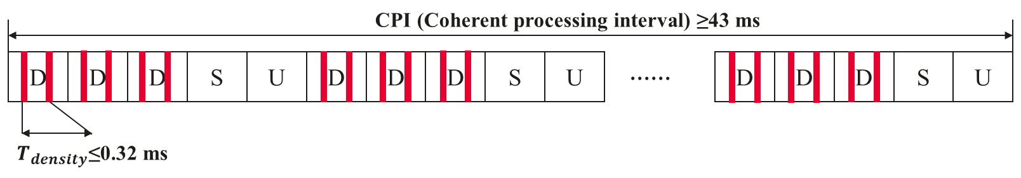
Figure 2: Illustration of coherent processing interval for doppler estimation.
Observation 4: To facilitate doppler estimation, UE needs to have the capability of phase continuity within a coherent processing interval (CPI) which crosses multiple UL and DL slots.
Another challenging issue is the synchronization between aNB and UEs. For aNB-UE/UE-aNB bi-static sensing, existing air interface synchronization designed for communication could be reused. However, the sensing results in terms of location or doppler estimation rely on the aNB/UE locations, reference path between UE and aNB, e.g. LoS path or reflected path, and/or synchronization accuracy. It is noted that UE’s location is the prerequisite for sensing results calculation and core network is responsible for maintaining UE positioning procedure.
If the UE-aNB link is in LoS state or the environmental static object related with reflected path is known a prior, the delay of reference path can be calculated. For UE-aNB/aNB-UE bi-static sensing, it detects the path related with targets and reference path, then estimates their differential delay which is not sensitive to over-the-air synchronization accuracy, e.g. UL TA accuracy. In this case, existing synchronization accuracy for communication might not be problems for sensing.
If the UE-aNB link is in nLoS state while environmental static object is unknown, the delay of reference path could be roughly estimated by using existing TA. But any DL and UL timing errors, e.g. TA errors, during the synchronization process could result in localization error. For example, the TA adjustment accuracy is defined as ±256 T_{c} for 30KHz SCS in NR, and the corresponding maximum distance estimating error is 19.2m exceeding the localization requirement of 5m for 6G sensing. Therefore, in this case, enhanced methods to estimate the delay of reference path or new synchronization methods should be further studied in collaboration with other WGs, e.g., RTT-based measurement, GNSS-based shared time source, etc.
Observation 5: For aNB-UE/UE-aNB bi-static sensing utilizing air interface synchronization, the accuracy of sensing results in terms of location or doppler estimation rely on synchronization accuracy when delay of reference path between UE and aNB is unknown a prior.
Similar with aNB mono-static sensing, aNB-UE and UE-aNB bi-static sensing have the issues of larger dynamic ranges of receiving signal power. This issue even goes more severe since both sensing modes mostly rely on the LoS path, which means there is a strong LOS path together with other much weaker scattering paths, the dynamic range might exceed 60-100dB as shown in [3].
Proposal 2: For aNB-UE/UE-aNB bi-static based vehicle sensing scenario, the feasibility study should consider the following issues:
- Phase continuity of UE when UL/DL switches for TDD system
- Synchronization between aNB and UE
- Sensing signal received sensitivity.
As for the prioritized bands to be investigated for 6G sensing, RAN1 has the following agreement for Rel-20 6G sensing performance evaluation. It is proposed to follow the band agreed in RAN1 as the start point of RAN4 study.
- Agreement
For Rel-20 6G sensing performance evaluation of object detection and/or tracking, the following cases/combinations are considered as baseline cases/combinations.
Sensing target | Indoor or outdoor | Scenario | Carrier frequency
UAV | Outdoor | UMa-AV, SMa | 4 GHz, ~7 GHz, 30 GHz (for UMa-AV only)
Human | Outdoor | UMa | 4 GHz, ~7 GHz, 30 GHz
 | Indoor | Indoor Hotspot | 4 GHz, ~7 GHz, 30 GHz
Vehicle | Outdoor | Urban Grid, Highway | 4 GHz, ~7 GHz, 30 GHz (for Urban Grid only)
AGV | Indoor | Indoor factory (SH) | 4 GHz, ~7 GHz, 30 GHz
- Note: sensing mode(s) for each row will be discussed
- Other cases/combinations can also be evaluated, reported and collected from companies.
Note: In this agreement, no intention to de-prioritize other scenarios or carrier frequencies.
Proposal 3: For study of 6G sensing, the prioritized bands could be restricted to 4GHz and ~7GHz for FR-1.

Conclusion
This contribution provides our further considerations on feasibility study for 6G sensing.
Observation 1: For aNB mono-static based UAV sensing scenario, aNB needs to transmit pulse and continuous wave-based signals to sense the short-ranged and long-ranged targets, respectively.
Observation 2: For pulse wave-based aNB mono-static sensing, TRP transmits and receives signals in a TDM manner, and the minimum sensing range is determined by the Tx-Rx switching time interval.
Observation 3: For continuous wave-based aNB mono-static sensing, aNB transmits and receives concurrently in a full-duplex manner, and needs to lower the transmit power under the restriction of Tx-Rx antenna panel isolation.
Proposal 1: For aNB mono-static based UAV sensing scenario, the feasibility study should consider the following issues:
- Tx-Rx switching time interval for pulse wave-based long-range sensing is restricted by the CP length of signals for continuous wave-based short-range sensing
- Tx–Rx antenna panel isolation for continuous wave-based short-range sensing
- Sensing signal received sensitivity for both the sensing methods.
Observation 4: To facilitate doppler estimation, UE needs to have the capability of phase continuity within a coherent processing interval (CPI) which crosses multiple UL and DL slots.
Observation 5: For aNB-UE/UE-aNB bi-static sensing utilizing air interface synchronization, the accuracy of sensing results in terms of location or doppler estimation rely on synchronization accuracy when delay of reference path between UE and aNB is unknown a prior.
Proposal 2: For aNB-UE/UE-aNB bi-static based vehicle sensing scenario, the feasibility study should consider the following issues:
- Phase continuity of UE when UL/DL switches for TDD system
- Synchronization between aNB and UE
- Sensing signal received sensitivity.
Proposal 3: For study of 6G sensing, the prioritized bands could be restricted to 4GHz and ~7GHz for FR-1.

References
- R4-2605009, Way Forward for [118bis][362] 6G_Sensing, ZTE, RAN4#118bis, St. Julian’s, Malta, April 13-17, 2026.
- R4-2605757, On 6GR Sensing use cases and sensing modes, Huawei, HiSilicon, RAN4#119, Dalian, China, May 18–22, 2026.
- R4-2603735, Discussion on 6G Sensing feasibility study, vivo, RAN4#118bis, St. Julian’s, Malta, April 13-17, 2026.

